Algebra 1: Unit 3, Lesson 6

- A cell phone company recorded the number of app sales each year since 2011. The data is displayed in the graph.
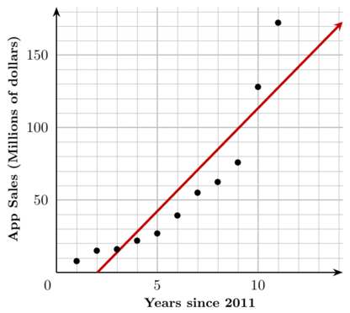
What type of association is there between the number of years since 2011 and the app sales?
strong positive

- A local supermarket recorded the number of items purchased along with the total price of each receipt. The store created a scatter plot and formally fit a line to the data using a graphing calculator. The screenshot shows the results of the supermarket generating a line, in slope-intercept form, to model the relationship between the number of items purchased, $x$, and the total cost, $y$.
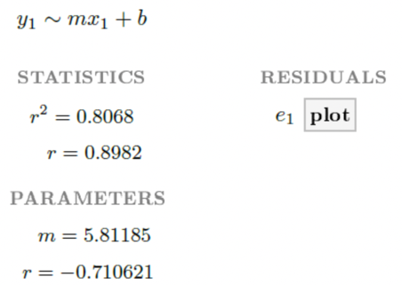
Using the output shown, what is the equation for the line of best fit?
$$y=5.81185x-0.710621$$

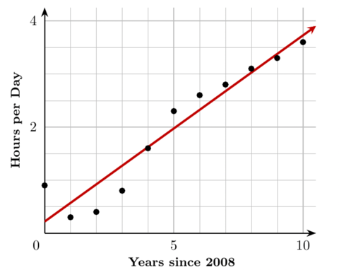
- The relationship between the number of hours a part-time employee works per day and the number of years since 2008 is shown in the graph.
A students was trying to determine if the $y-$intercept of the line of best fit is $(0,0.22)$ or $(0,0.9)$. What is the $y-$intercept?
(0,0.22)

